Q1.The scope of physics is very wide. It covers a vast variety of Natural Phenomena. Observe your surroundings and explain one application of physics in day to day life.
Q2. Observe your surroundings and mention any five reasons why you need to measure.
Q3. Pick any five objects from your surroundings of different matter and dimensions. Make a table as below with suitable units:
Name of the Object | Length/Breath/Height | Weight/Area/Volume | Dimensional Formula
Matchbox | 5cm/ 3cm/ 2cm | 25 g/ -/ 30cm³ | L³
Q4.In ancient time when there was no standard system of measurement. Human body parts were used as units for measurement.
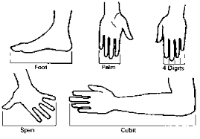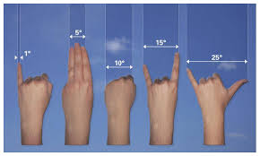
Explain in your own words why human body parts rejected as units for measurement.
Q5. For measurement, each physical quantity is assigned SI unit such that meter for Distance. It can be converted in different units by keeping prefix for power of ten. For example 10⁻²meter = centimeter and 10³ meter = Kilometer and so on. Explain why do we need different units for the same physical quantity?
Q.6.Pick any object from home or school and measure it by suitable scale. After measuring convert the measured units into three different units of that quantity.
Q7. Give an example of:
- A physical quantity which has neither unit nor dimensions.
- A physical quantity which has a unit but no dimensions.
- A constant which has no unit.
- A constant which has a unit.
Q8.Mention 3 scalar quantities and 3 vector quantities from surroundings. Write your comments why scalar quantities are different than vector quantities and also comment why we need vectors?
Q9. Push your study table in a certain direction with a force of magnitude say 10N. At the same time ask your mother, sister or brother to push the same table with a force of magnitude say 15N. Calculate the magnitude of the resultant force on study table and its direction when forces are acting in same direction and when forces are acting in opposite direction to each other.
Q10. Find the area of the triangle whose vertices are A(3, - 1, 2), B(1, - 1, - 3) and C(4, - 3, 1) using suitable vector product.

