NIOS/Acad./2020/315/02/E

National Institute of Open Schooling
Senior Secondary Course - History
Lesson 2 : The Geographical settings and pre historic cultures of India
Worksheet - 2

On the given political outline map of India, mark and name the following.
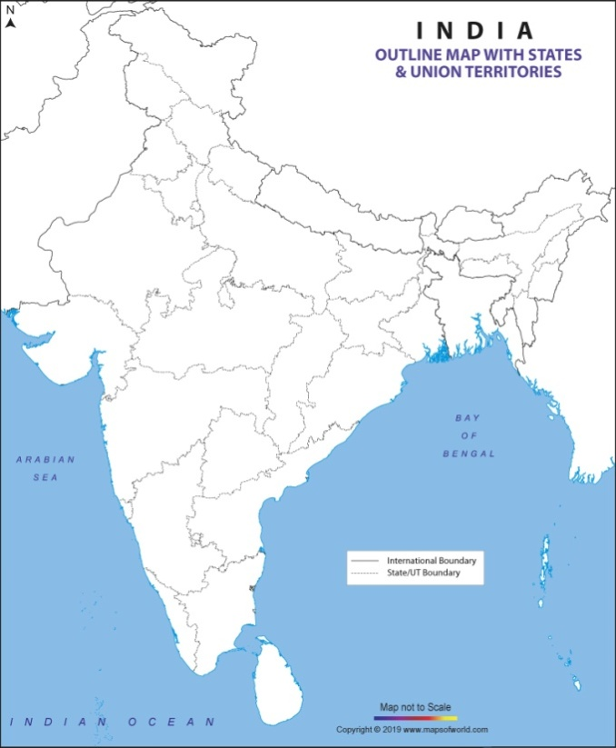
Q.1 Two Palaeolithic sites.
Q.2 Two Neolithic sites.
Q.3 Mark the place where Bhimbetka caves are located.
For CWSN-
Q.1 Name two Palaeolithic sites.
Q.2 Name two Neolithic sites.
Q.3 Name the place where Bhimbetka caves are located.
Q.4 Describe the dynamic change in handicraft and pottery with the present time.
Q.5 Differentiate between Palaeolithic and Neolithic tools.
Q.6 Analyse the purpose of Bhimbetka cave paintings.
Q.7 Analyse the chief characteristics of Palaeolithic cultures.
Q.8 Explain the geographical distribution of the Palaeolithic sites and mark on the outline map of India.
Q.9 Write a note on the life of the non-Harappan Chalcolithic people.
Q.10 Describe the chief characteristics of Neolithic cultures.

