NIOS/Acad/2020/302/03/E
National Institute of Open Schooling
Senior Secondary Course
Lesson 3: Reading With Understanding
Worksheet – 3

Read the following passage carefully and answer the questions that follow.

- It’s a busy world. You fold the laundry while keeping an eye on the kids and another on the television. You plan your day while listening to the radio and commuting to work, and then plan your weekend. But in the rush to accomplish necessary tasks, you may find yourself losing your connection with the present moment—missing out on what you are doing and how you are feeling. Did you notice whether you felt well-rested this morning or that sunflower is in bloom along your route to work?

- Mindfulness is the practice of purposely focusing your attention on the present moment—and accepting it without judgment. Mindfulness is now being examined scientifically and has been found to be a key element in happiness.

- The cultivation of mindfulness has roots in Buddhism, but most religions include some type of prayer or meditation technique that helps shift your thoughts away from your usual preoccupations toward an appreciation of the moment and a larger perspective on life.

- Professor Emeritus Jon Kabat-Zinn, founder and former director of the Stress Reduction Clinic at the University of Massachusetts Medical Centre, helped to bring the practice of mindfulness meditation into mainstream medicine and demonstrated that practicing mindfulness can bring improvements in both physical and psychological symptoms as well as positive changes in health attitudes and behaviours.

- Mindfulness improves well –being. Increasing your capacity for mindfulness supports many attitudes that contribute to a satisfied life. Being mindful makes it easier to savour the pleasures in life as they occur, helps you become fully engaged in activities, and creates a greater capacity to deal with adverse events. By focusing on the here and now, many people who practice mindfulness find that they are less likely to get caught up in worries about the future or regrets over the past, are less preoccupied with concerns about success and self-esteem, and are better able to form deep connections with others.

- Mindfulness improves physical health. If greater well-being isn’t enough of an incentive, scientists have discovered the benefits of mindfulness techniques which help improve physical health in a number of ways. Mindfulness can help relieve stress, treat heart disease, lower blood pressure, reduce chronic pain and improve sleep.

- Mindfulness improves mental health. In recent years psychotherapists have turned to mindfulness meditation as an important element in the treatment of a number of problems, including depression and substance abuse.

- Some experts believe that mindfulness works, in part, by helping people to accept their experiences—including painful emotions—rather than react to them with aversion and avoidance.

- It’s become increasingly common for mindfulness meditation to be combined with psychotherapy, especially cognitive behavioural therapy. This development makes good sense, since both meditation and cognitive behavioural therapy share the common goal of helping people gain perspective on irrational,maladaptive and self-defeating thoughts.

Answer the following questions according to your understanding of the passage:

- What does mindfulness promote?
_________________________________________________________________________________

- What has been found to be a key element in happiness?
_________________________________________________________________________________

- According to the passage, mindfulness has its root in which religion?
__________________________________________________________________________________

- How do we know that mindfulness improves physical health?
__________________________________________________________________________________

- What effect does mindfulness have on mental health?
___________________________________________________________________________________

- Why is mindfulness being combined with psychotherapy these days?
___________________________________________________________________________________

- Find words from the passage which are similar in meaning to the following:
i) hostile, unfavourable (para 3) ______________________
ii) hatred (para 8) _______________________

- Look at the image given below. Write down two ways that appeal to you to achieve mindfulness.

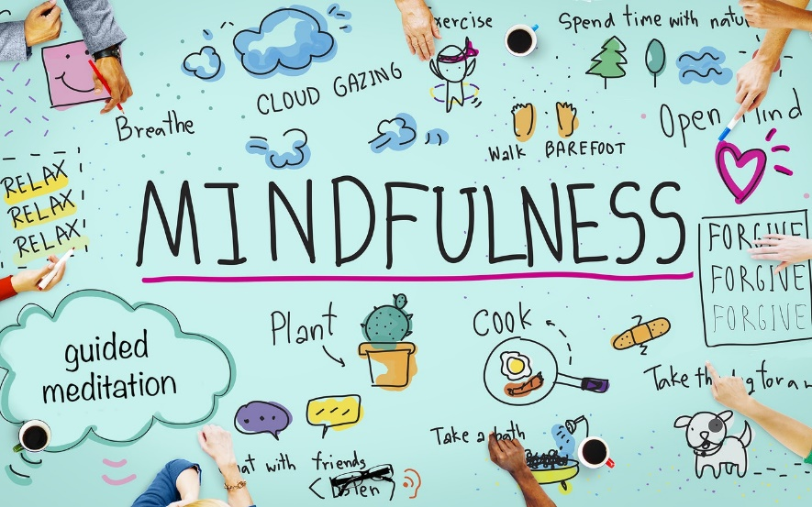

- ____________________________________________________________________________

- ____________________________________________________________________________

- Is there any book /talk show/person that has given you invaluable advice and motivation to lead a mindful life? Mention it/ them here.
__________________________________________________________________________________

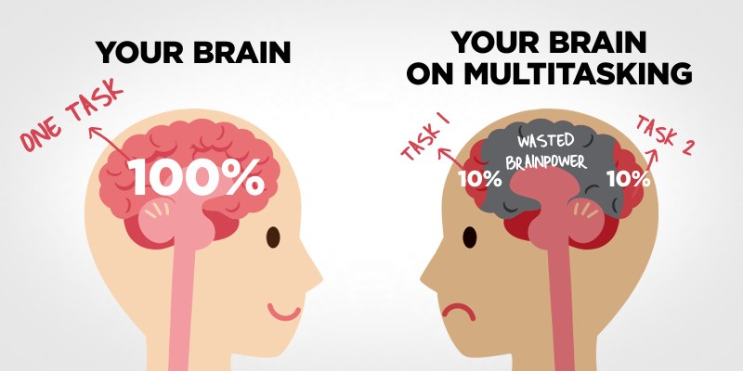
- Research confirms that monotasking--and not multitasking--is the secret to getting things done. You may think you can do everything right now, but you can't--and you shouldn't. So, instead of multitasking, you should focus on monotasking--where you focus on only one initiative at a time.

So, multitasking or monotasking? What would you prefer? Reflect about it. Read up about it and then give your opinion in about five sentences.

